Category

[Cleaning & Household](https://www.bigbasket.com/cl/cleaning-household/)[Detergents & Dishwash](https://www.bigbasket.com/pc/cleaning-household/detergents-dishwash/)[Detergent Bars](https://www.bigbasket.com/pc/cleaning-household/detergents-dishwash/detergent-bars/)[Detergent Powder, Liquid](https://www.bigbasket.com/pc/cleaning-household/detergents-dishwash/detergent-powder-liquid/)[Dishwash Bars & Powders](https://www.bigbasket.com/pc/cleaning-household/detergents-dishwash/dishwash-bars-powders/)[Dishwash Liquids & Pastes](https://www.bigbasket.com/pc/cleaning-household/detergents-dishwash/dishwash-liquids-pastes/)[Fabric Pre, Post Wash](https://www.bigbasket.com/pc/cleaning-household/detergents-dishwash/fabric-pre-post-wash/)[Imported Home Care](https://www.bigbasket.com/pc/cleaning-household/detergents-dishwash/imported-home-care/)[Brands](https://www.bigbasket.com/pb/all-brands/)[Surf Excel](https://www.bigbasket.com/pb/surf-excel/)[Surf Excel Detergent Powder, Liquid](https://www.bigbasket.com/pb/surf-excel/detergent-powder-liquid/)

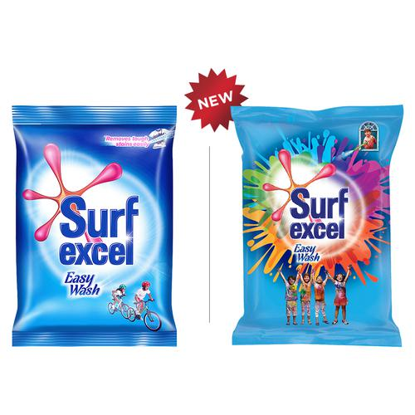

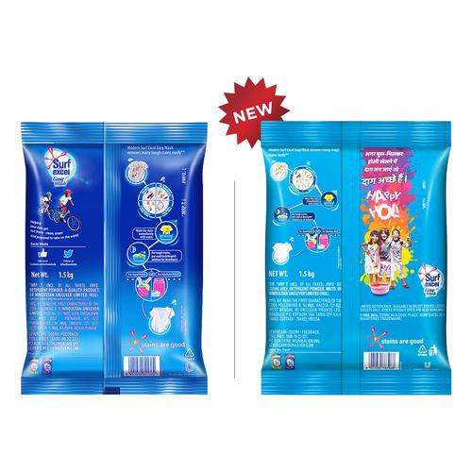

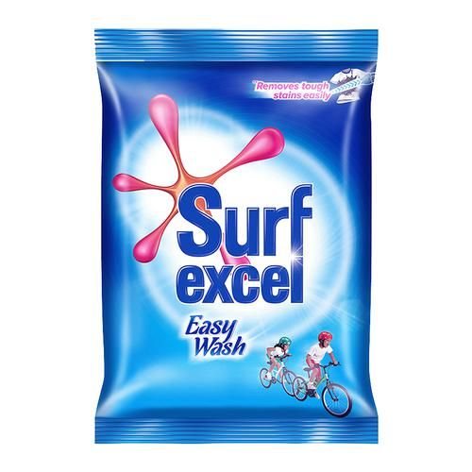

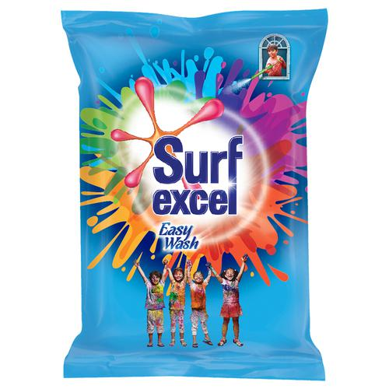

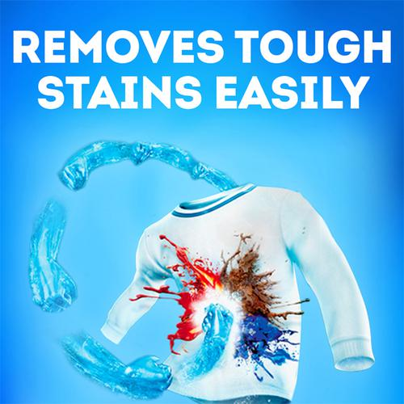

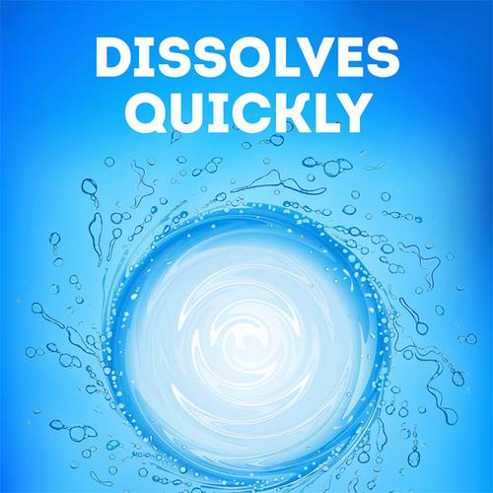

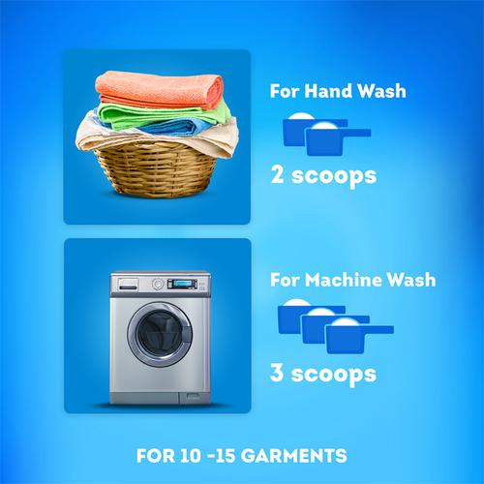

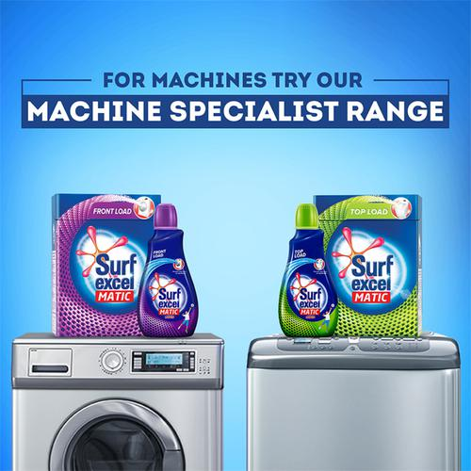

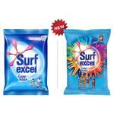

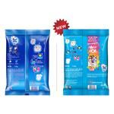

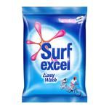

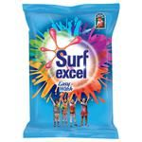

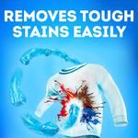

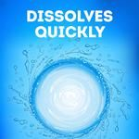

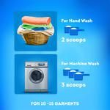



[Surf Excel](https://www.bigbasket.com/pb/surf-excel/)

Surf Excel Easy Wash Detergent Powder, 1.5 kg

|  |  |
| --- | --- |
| MRP: | ~~Rs 186~~ |
| Price: | Rs 138.70 |
| You Save: | 25% |
|  | (Inclusive of all taxes) |

4.3

14434 Ratings & 354 Reviews



ADD TO BASKET

SAVE

Standard: Tomorrow Morning

Pack Sizes

1.5 kg

Rs 138.70MRP: ~~Rs 186~~25% Off

3 kg

Rs 300

4 kg

Rs 436MRP: ~~Rs 496~~12% Off

500 g

Pouch

Rs 50

1 kg

Rs 100

+2 More Combo's

Surf Excel Easy Wash Detergent Powder

About the Product

With Surf excel Easy Wash, now remove tough stains easily with the power of ten hands. We understand that washing clothes and removing stains can be extremely tiring and cumbersome. Especially if you are a mother of a young kid who fills your laundry basket with clothes covered in an array of stains, grass stains from football practice, ketchup stains from lunch and paint stains from art class. Until now you would have to soak your childs dirty clothes for a couple of hours and then scrub them with your hands using a brush and a bar, and wondered why it takes so much time and effort to remove stains from your kids clothes? The answer is because regular detergents do not dissolve completely and dont work as effectively. Surf excel Easy Wash is a superfine powder that removes tough stains in a jiffy and leaves no residue on your clothes. Being a superfine and fluffy powder it dissolves easily and reaches the stain and removes it easily. Its engineered formula with a superior technology unleashes the power of 10 Hands that is effective in removing toughest of the stains such as mud, ink, oil, ketchup, curry stain and chocolate very easily.  
Features and Benefits:  
• Surf excel Easy Wash has the power of 10 hands that removes tough stains easily• Its a superfine powder that dissolves easily and removes tough stains fast.• Its superior technology fights various tough stains such oil, ketchup, chocolate, curry stains• For tough stains, pre-soak you garments in Surf excel Easy Wash solution for 30 mins• Hand-wash - Use 2 scoops of Surf excel Easy Wash ; Machine-wash - Use 3 scoops of Surf excel Easy Wash• It works on coloured as well as white garments.

How to Use

Take required amount of powder in while the washer is filling, but before adding the clothes.